HU CI/CD Assignment — GitHub Actions & Jenkins

Steup Jenkins via docker
docker run -d --name q1-jenkin ^
-u 0:0 ^
-p 8080:8080 -p 50000:50000 ^
-v jenkins_home:/config ^
-v /var/run/docker.sock:/var/run/docker.sock ^
ghcr.io/imagegenius/jenkins:latest

Question 1
Build a Jenkins pipeline that:
- Builds a Docker image for a sample application.

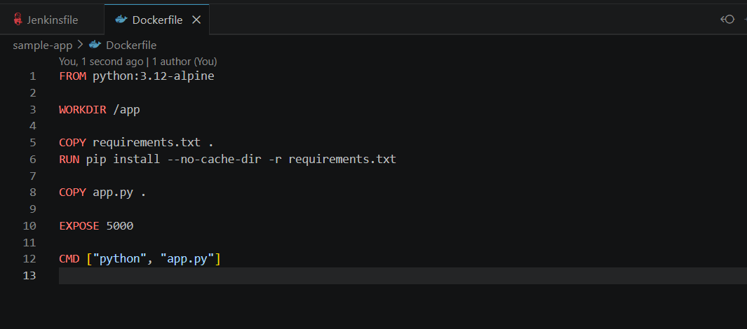
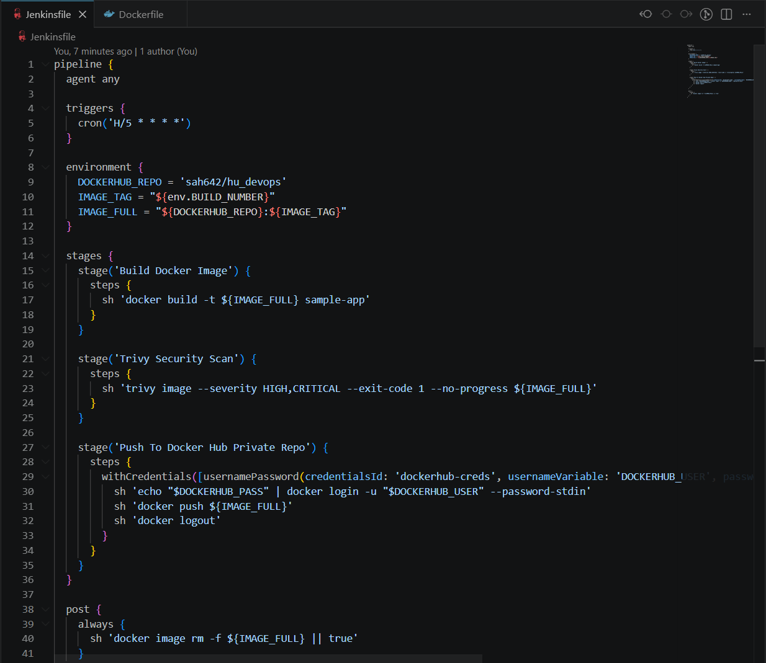
2. Scans the image with Trivy as a test/quality gate — the pipeline should fail if any HIGH or
CRITICAL vulnerabilities are found.

Scan 10

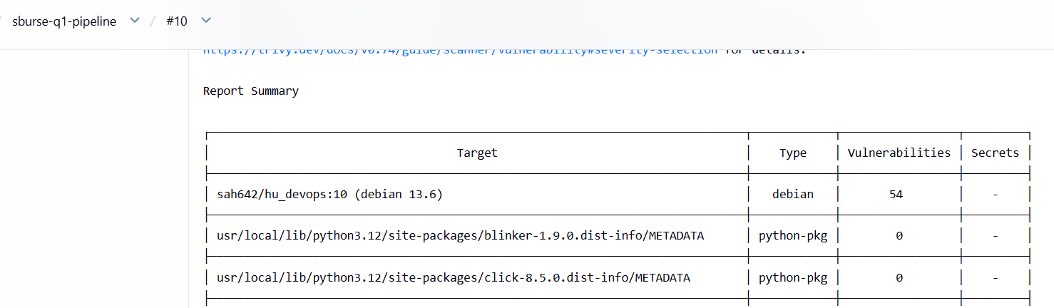
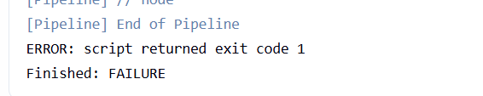

Scan 11
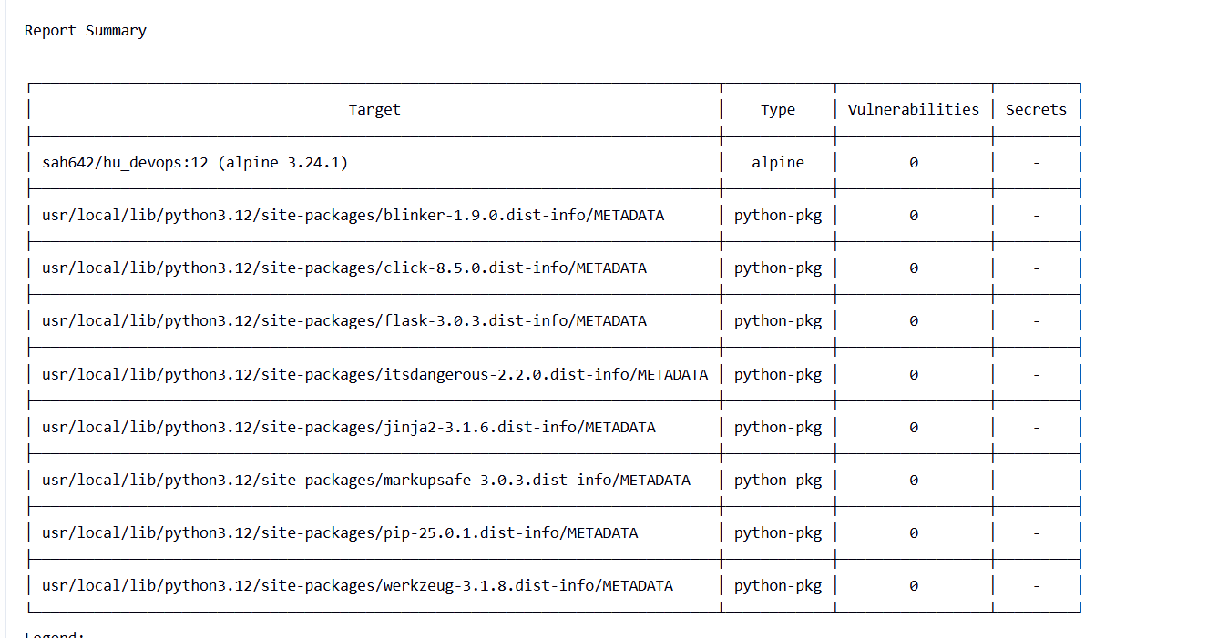

- Pushes the image to a private Docker Hub registry.
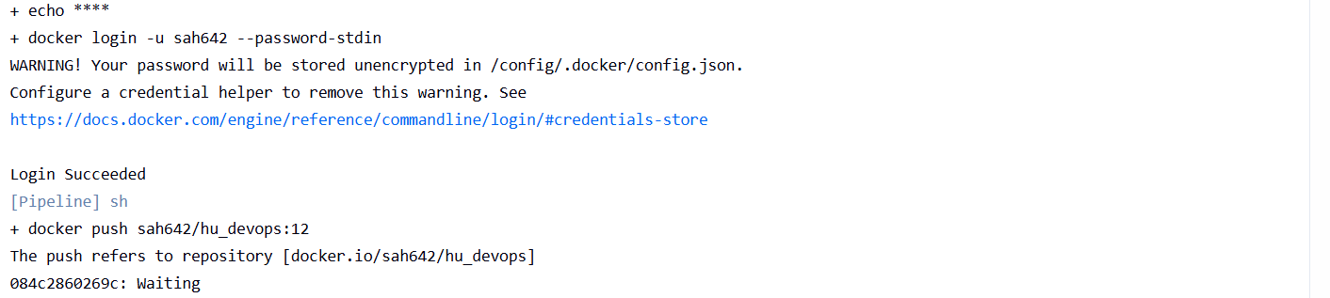
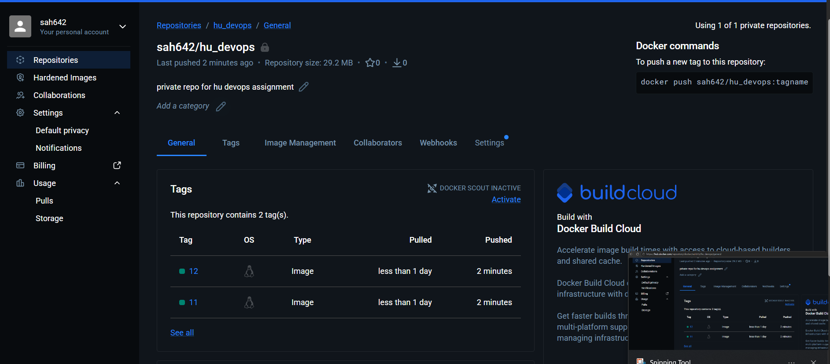
4. Runs both on-demand (manual trigger) and on a schedule — configure it to also trigger
automatically every 5 minutes.
